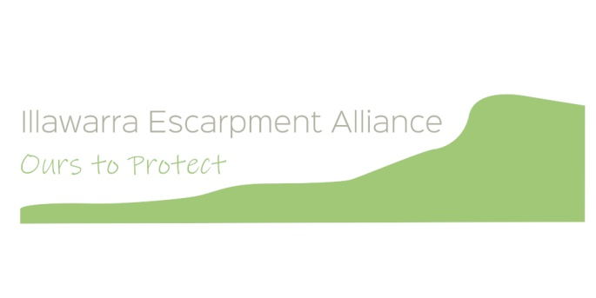

XXX October 2022
BY EMAIL: illawarra-highlands@npws.nsw.gov.au

To whom it may concern
Illawarra Escarpment Alliance (EscA) submission on proposed amendment to the Plan of Management (PoM) for the Illawarra Escarpment State Conservation Area (IESCA)
The Illawarra Escarpment Alliance (EscA) is an alliance of community-based organisations and likeminded individuals, established in 2019 to focus collaborative efforts to protect the cultural and environmental values of the Illawarra Escarpment in its entirety.
EscA appreciates the opportunity to comment on the draft amendment to the IESCA PoM, and provides the following general and specific comments.
General comments
EscA supports the development of robust and detailed Plans of Management that provide clarity on what is permitted and what is not permitted in areas within the national parks estate.
We believe that the draft amendment to the IESCA PoM is so broadly drafted that it does not include adequate detail on what would or would not be permitted, and that it potentially allows activities that are not consistent with the National Parks and Wildlife Act (1974).
EscA does not support the proposed amendment as it stands.
Great Southern Walk camping area
EscA supports in principle initiatives by the National Parks and Wildlife Service (NPWS) to support culturally and environmentally sustainable use of the IESCA, consistent with the National Parks and Wildlife Act 1974, including through provision and maintenance of appropriate trails and associated amenities for walking in the IESCA.
EscA:
- wants the IESCA to provide camp sites without built structures as the predominant on-park option for overnight stays;
- supports use of off-park accommodation options as a first preference. In peri-urban areas such as the IESCA, all efforts should be made to avoid building new accommodation within the national parks estate.
If accommodation beyond camping is to be considered within the IESCA, EscA asks that, such accommodation should:
- be located in areas that are already disturbed and of low ecological value, and that make use of existing vehicle access;
- be constructed and managed directly by NPWS, with no commercial operators allowed;
- be simple, basic and affordable to all, designed to have minimal environmental impact during construction and operation (e.g. no on-site waste management, no running water, no electricity);
- be implemented in conjunction with activities to restore disturbed/degraded vegetation;
- be accessible to walkers seeking to stay for a single night rather than requiring them to book a multi-night walk.
EscA submits that any such accommodation should only be approved subject to the completion and approval of a comprehensive and publicly exhibited environmental impact assessment.
EscA strongly objects to the current vague wording in the proposed amendment to the PoM in regard to what may and may not be permissible. We ask that NPWS modify the wording of the amendment to specifically rule out design, construction, operation or management of camp sites by a commercial operator.
Other changes – rock climbing
EscA supports a PoM for the IESCA that clearly specifies where rock climbing may (and may not) occur within the IESCA, and stipulates the conditions under which it is allowed.
EscA does not support the proposal in the draft PoM amendment that the entire 13km area north of Bulli be available for rock climbing with no restrictions. This is inappropriate because it will have potentially significant impacts on cultural and environmental heritage values within the IESCA. For example, cliff areas within the IESCA host important assemblages of vegetation and plants, such as protected rare orchid species like Bulbophyllum minutissimum.
- Any proposal to open part/s of the IESCA to rock climbing should be subject to appropriate environmental impact assessment through a mechanism such as a review of environmental factors that is publicly exhibited. This should be specifically noted in the PoM.
- Areas in the IESCA that are approved for rock climbing should be specified in detail in the PoM.
We note that the Illawarra chapter of Australian Climbing Association (NSW) supports identifying the areas in which rock climbing will be allowed in the IESCA PoM.
Other changes – increase in numbers allowed to undertake certain activities without written permission
EscA does not support any of the proposed changes to the PoM (reference p.30, under Management Response) regarding changes to the limits of group activities without written consent. The draft PoM amendment provides absolutely no context, explanation or justification for the proposed changes to the limit of group activities allowed without written consent.
The proposed substantive changes to the PoM relate only to camping and rock climbing, not to cycling or horse riding. There is zero rationale provided for making changes in relation to cycling, horse riding or ‘other activities.’
EscA submits that the limit of group activities without written consent should stay as:
- cycling, including mountain biking: 20 people
- horse riding: 8 horses
- rock climbing: 4 per roped party
- walk-in camping: 16 people
- other activities: 20 people.
Thank you for the opportunity to comment. We look forward to seeing the details of this submission being incorporated into the IESCA PoM.
Please do not hesitate to contact us if you would like further details in relation to the submission.
Submitted on behalf of EscA by Emma Rooksby
info@illawarraescarpment.org
www.illawarraescarpment.org

